HTTP Request
28 Februari 2017
16:03

HTTP Client:
- Browser
- Command Line (curl)
- Script (php) :
  - Curl (library): php 5.6 (curl include in library)
  - Internal function of php ( file_get_contents() )
  - External library (Guzzle)

Php web client using Curl:

Example-01:
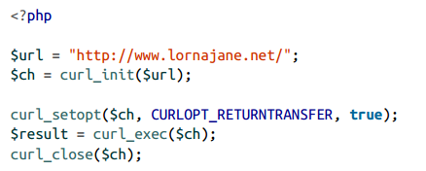

Example-02:

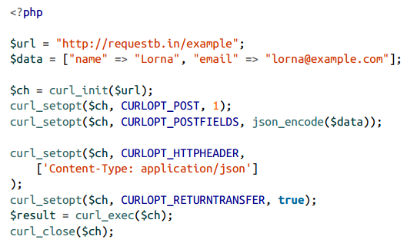

Example-03:
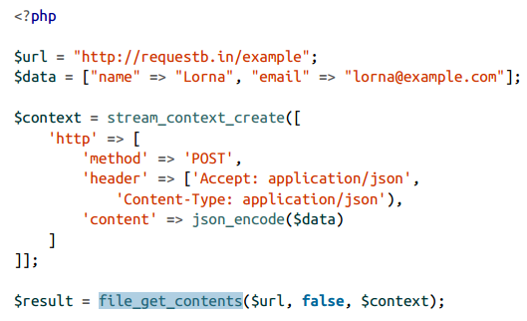

Installing Guzzle
- Download "composer"

